NetBurner Default Settings

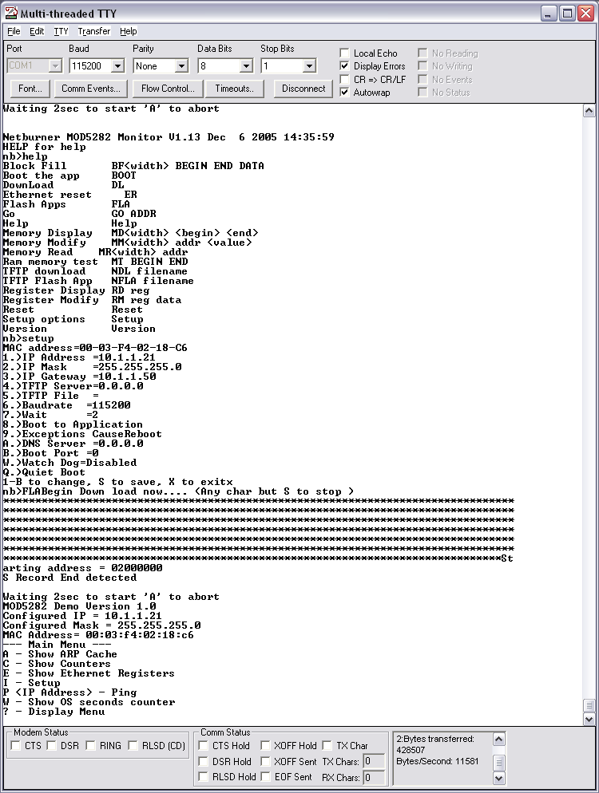

PORT = COM2

Baud = 115200

IP Address = 10.1.1.? (The IP address of your NetBurner Board.)

IP Gateway = 128.208.244.? (The IP address of your PC host.)

